**LESSON-2**

**THE WORLD OF GREEN**

**I. Word focus**

1. Fibrous root
2. Tap root
3. Shrub
4. Herb
5. Climber
6. Creeper
7. Absorb
8. Nutrients
9. Shoot
10. Support
11. Firmly

**II. Who am I?**

1. The part of the plant which grow below the ground.

Root

1. The hard protective outer layer of the tree.

Bark

1. The plants with weak stem and needs support to grow.

Climber

1. A plant that get nutrients from eating insects.

Venus fly trap

**III. Answer the following**

1. Write the differences between tap root and fibrous root.

|  |  |
| --- | --- |
| Tap root | Fibrous root |
| It has 1 main root and many side roots. | It has many thin roots and no main root. |
| The root goes deep into the soil. | The roots do not go deep into the soil. |
| Can store food. | Cannot store food. |
| Eg: carrot, radish, coriander, tulsi | Eg: wheat, grass, rice and corn |
|  |  |

1. How does a root help the plant?

Root hold the plant firmly in the soil.

Root absorbs water and nutrients from the soil.

1. Why leaves are the most important part for a plant?

Leaves are important part for a plant as they make food for the plant.

1. Write difference and similarity between climber and creeper.

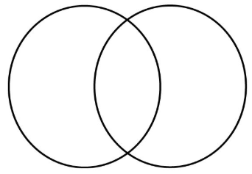

**Both plants have weak stem**

**Creeper**

Grows along the ground.

Eg: pumpkin, water melon

**Climber**

To grow upwards, it needs support.

Eg: grapevine

1. Write the difference between shrub and herb.

|  |  |
| --- | --- |
| Herb | Shrub |
| Herbs are short plants. | Shrub is larger than herb but smaller than a tree. |
| It has thin, green, non woody stem. | It has hard woody stem. |
| Eg: mint, grass, coriander | Eg: rose, jasmine, lemon, tulsi |

**IV. Interactive activity - Make paper collage of tree**

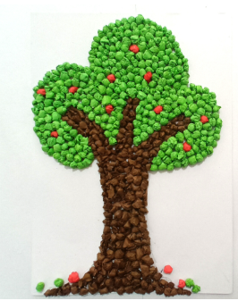**Features of trees**

**Big plants are called trees.**

**It has many branches.**

**It has strong thick woody stem.**

**Eg: neem, banyan, mango**

**The hard outer layer of trunk is called bark.**

**Bark protects the tree.**